Functional Design

HypeBest

Table of content

1 Introduction 4
1.1 Actual Situation and history 4
1.2 Objectives 4
2 Scope, premises and restrictions 4
3 Conceptual Design 4
3.1 General description of the system 4
3.2 Context and interfaces 4
4 Design of the architecture 5
4.1 Requirements related to the architecture 5
4.2 Scenario and elements of the architecture 5
4.2.1 Components of the architecture 5
4.2.2 Operating systems and hardware architecture 6
4.2.3 Scenario Diagrams 6
4.3 Software architecture 6
4.3.1 Software components and integration model 6
4.3.2 Correspondence software components / system functions 6
5 External Design 7
5.1 Layout standards and style guides 7
5.1.1 Screen standards 7
5.1.2 Report and document standards 8
5.2 Details of user screen interface 8
5.2.1 Flow chart for navigation of the interface 8
5.2.2 Summary of user interfaces – Screens and windows 9
5.2.3 Details of the user interfaces – Screens and windows 9
5.2.3.1 U. I. screen (1...n) 9
5.3 Details of the user interface for reports 10
5.3.1 Report (1 ... n) 10
5.4 Details of the user interface for documents 10
5.4.1 Document (1 ... n) 10
5.5 Interfaces with other systems / applications 10
5.5.1 System Interface – (1...n) 10
5.5.1.1 Description of the interface concept 11
5.5.1.2 External system 11
5.5.1.3 Content 11
6 Logical Data Model 12
6.1 Entity-Relation Diagram 12
6.2 Entity details 13
6.2.1 Entity (E - 1..n) 13
6.2.1.1 Entity description 13
6.3 Relations between entities 13
6.4 Data Dictionary 13
7 Logical Process Model 15
7.1 Details of the subsystems 15
7.1.1 Layers or system partitions 15
7.1.1.1 Details of the subsystem 1...n 15
7.2 Detailed design of basic functions (structured design) 15
7.2.1 Function AAAAAAA (1...n) 15

Introduction

Il progetto HypeBest si propone di creare un prodotto strutturato in modo tale da rispondere all’esigenza di gestire la condivisione di outfit basati su un indumento, attraverso l’utilizzo di un sito web o di un’applicazione smartphone per sistemi operativi Android e IOS.

Lo scopo è quello di permettere ad una persona che cerca ispirazione per un outfit partendo da un capo d’abbigliamento di trovarne diversi, caricati precedentemente da altri utenti.

Actual Situation and history

L’applicazione punta a risolvere problemi legati alla creazione di un outfit da parte di un singolo utente, il quale riscontra la necessità di ricercare nuovi outfit da indossare basandosi sulla situazione o su un capo che vuole utilizzare.

L’applicazione sarà in grado di gestire la condivisione di contenuti tra chi carica e chi ricerca.

Non si presenta nessun business process o business model per il cliente.

Objectives

Si cerca di ottenere un’applicazione software user-friendly che permetta anche all’utente inesperto di consultarla.
L’obiettivo principale è quello di ottenere una grafica semplice ed intuitiva ma allo stesso tempo completa

L’interfaccia proposta dal programma, sfruttando una grafica semplice ed intuitiva, permette all’utente di caricare foto del proprio outfit, e cercare e visionare contenuti già caricati da altri utenti. L’ambiente di lavoro sarà multi-finestra, con la possibilità di effettuare diverse operazioni, tra cui: caricamento, visualizzazione e ricerca.

Scope, premises and restrictions

- Le figure che influenzano lo sviluppo del sistema sono:
- Team di sviluppo
- Impiegati
- Developers (Analisti, Progettisti)
- Utenti
- Il sistema dovrà consentire la gestione delle pubblicazioni da parte degli utenti
  - Il sistema dovrò consentire di pubblicare foto del proprio outfit.
  - Il sistema dovrà consentire all’utente di aggiungere informazioni specificate nel punto
  - Il sistema dovrà consentire la cancellazione delle foto in qualsiasi momento.
  - Una volta terminato la fase, il sistema dovrà ripetere il passo a.
    - Il sistema dovrà consentire la gestione dei filtri

2.1.1.1 Quando l’utente effettuerà la ricerca di una determinata caratteristica dell’outfit, il sistema fornirà i risultati collegati ad essa.
    - Il sistema dovrà consentire la gestione degli utenti

2.1.2.1. Il sistema dovrà consentire agli utenti un accesso semplice

2.1.2.2. Il sistema dovrà permettere la creazione di un nuovo utente tenendo

conto dei requisiti 2.2.4

2.1.2.3. Il sistema dovrà permettere la modifica del nickname di un utente

2.1.2.4. Il sistema dovrà consentire all’utente di cancellare il proprio account

2.1.3 Il sistema tramite appositi bottoni darà la possibilità all’utente di muoversi tra le pagine disponibili, quali:
- Home
- Pagina caricamento foto
- Pagina di ricerca
- Pagina profilo utente
- Login/registrazione

2.1.4 Le funzionalità disponibili all’avvio dell’applicazione sono le seguenti:
- Visualizza nella home i contenuti suggeriti dal sistema
- Ricerca outfit
- Profilo dell’utente
- Caricamento dei contenuti
- Login/registrazione

    - La pubblicazione di una foto prevede:
- Che l’utente sia loggato
- Che siano inseriti i criteri per la ricerca del post (tag)

Opzionalmente si possono aggiungere:
- Una descrizione
- dei “tag” che etichettano i modelli dei capi di abbigliamento presenti nella foto e che indicizzano il sito web dove possono essere acquistati
- collegamenti ad altri profili (generalmente inserito se nel post sono presenti altri utenti dell’applicazione).

2.1.6 La ricerca di un indumento prevede l’inserimento di possibili campi:
- Colore dell’indumento
- Modello dell’indumento
- Marca dell’indumento
- Situazione per l’utilizzo di un outfit d’abbigliamento
- Sesso

    - Un utente generico è caratterizzato da:
- Cognome
- Nome
- Nickname
- Data di nascita
- E-mail
- Genere
- Id
    - Un post può essere eliminato in qualsiasi momento dall’utente che lo ha caricato.

  - Requisiti di sicurezza
    - Si riscontra l’esigenza di fornire un’adeguata sicurezza in merito all’accesso al proprio account. Ciò viene garantito dalla richiesta di una mail e di una password (minimo 8 caratteri, un numero ed una lettera maiuscola) “crittografata”

Conceptual Design

L’unica necessità dell’utente è quella di avere uno smartphone sul quale installare l’applicazione. Avviata per la prima volta l’applicazione mostrerà una schermata dove bisognerà accedere al proprio profilo e la possibilità di crearne un profilo in caso non se ne fosse provvisti. Una volta effettuato l’accesso, l’utente sarà indirizzato nella home dove gli verranno visualizzati alcuni post selezionati dal sistema. Nella stessa pagina nella parte inferiore saranno visualizzati dei bottoni per poter navigare all’interno dell’applicazione. Questi bottoni saranno dei collegamenti alle altre schermate:
- Una aprirà la pagina di ricerca, che tramite appositi filtri permetterà di visualizzare i post che rispondono ai nostri criteri.
- Un’altra pagina permetterà di aggiungere un post qualora ne fossero rispettati i requisiti descritti nel punto 2.1.5
- una mostrerà il profilo dell’utente (che potrà essere modificato) nella quale verranno mostrati i post, la biografia, il numero di follower, il numero dei post inseriti e il numero dei salvataggi effettuati per i propri post.

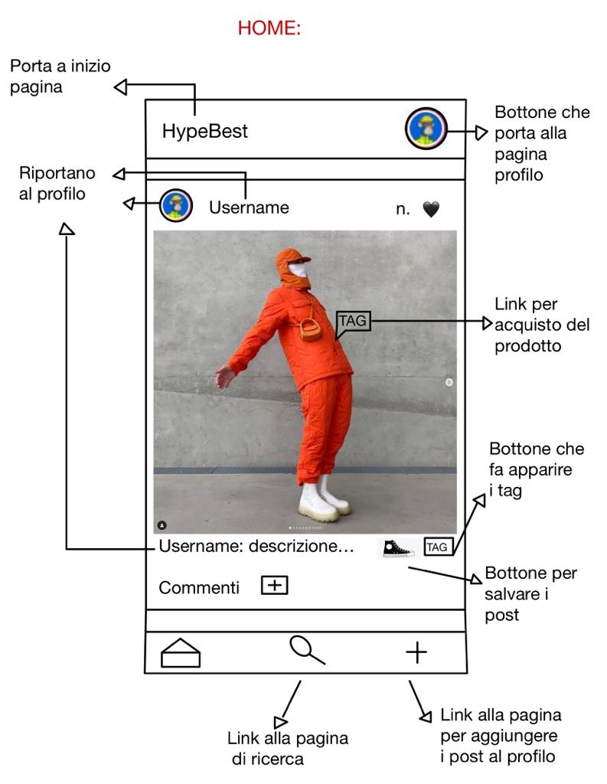

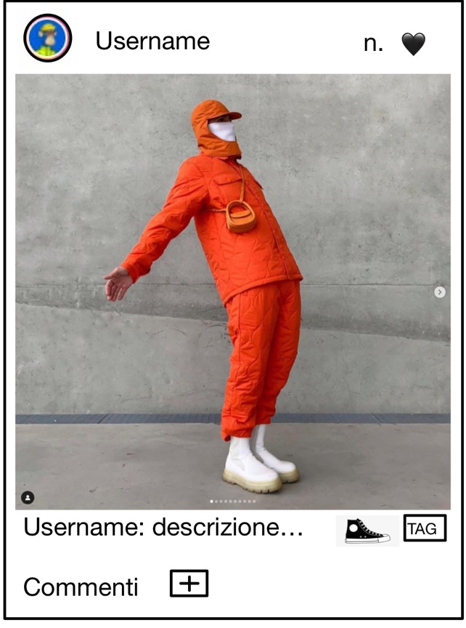

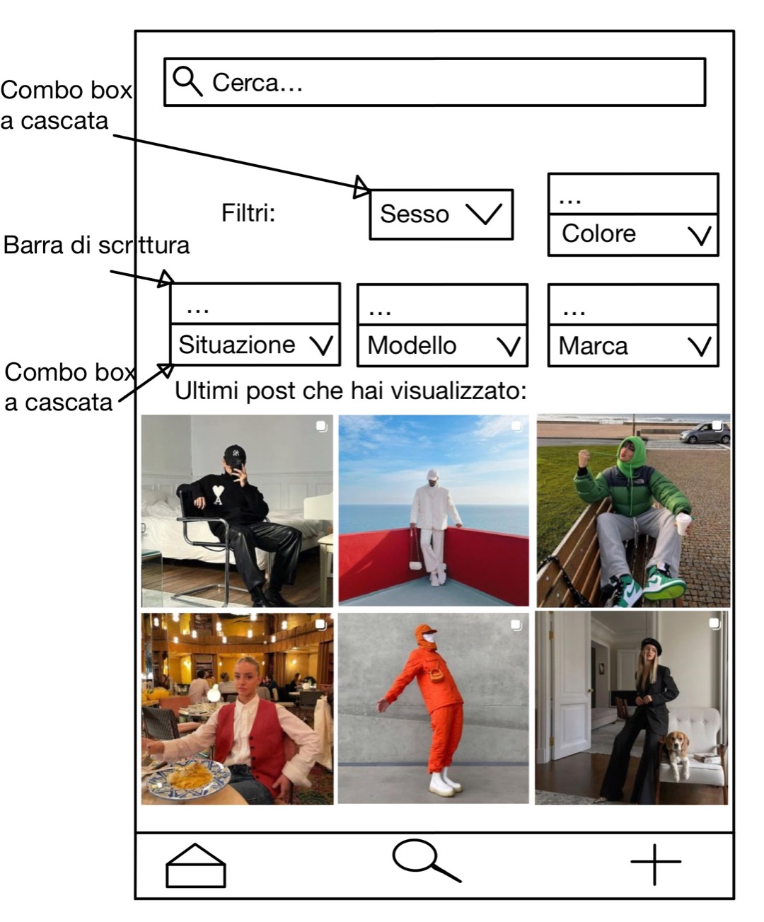
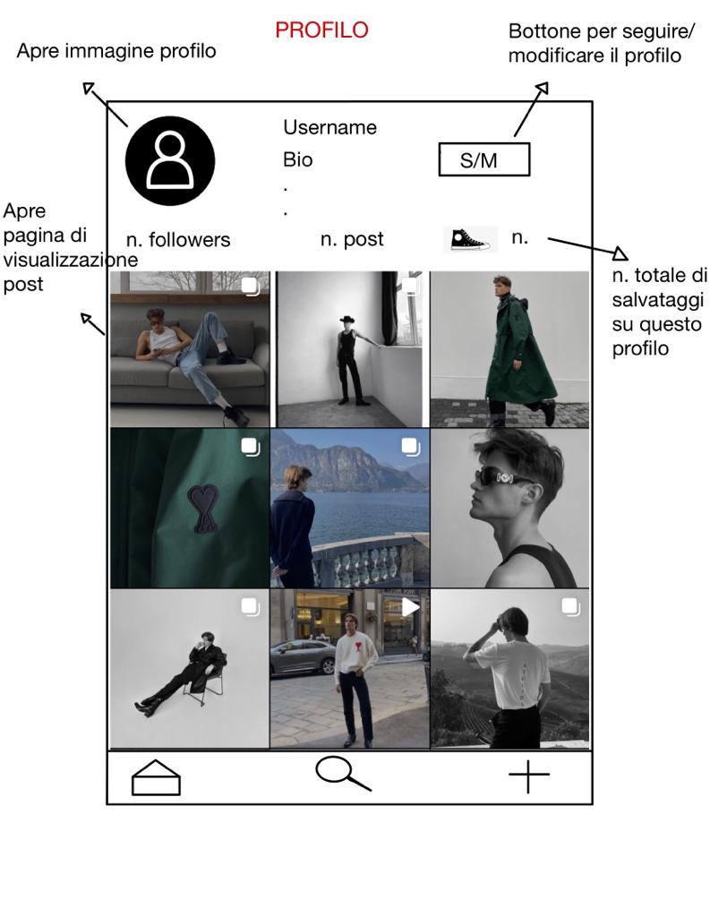

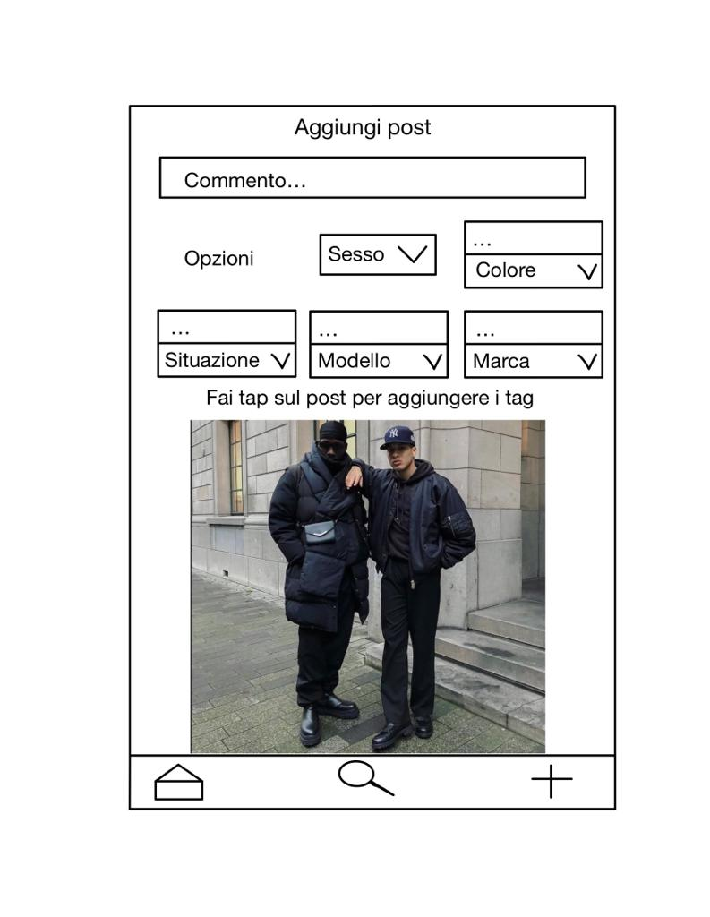
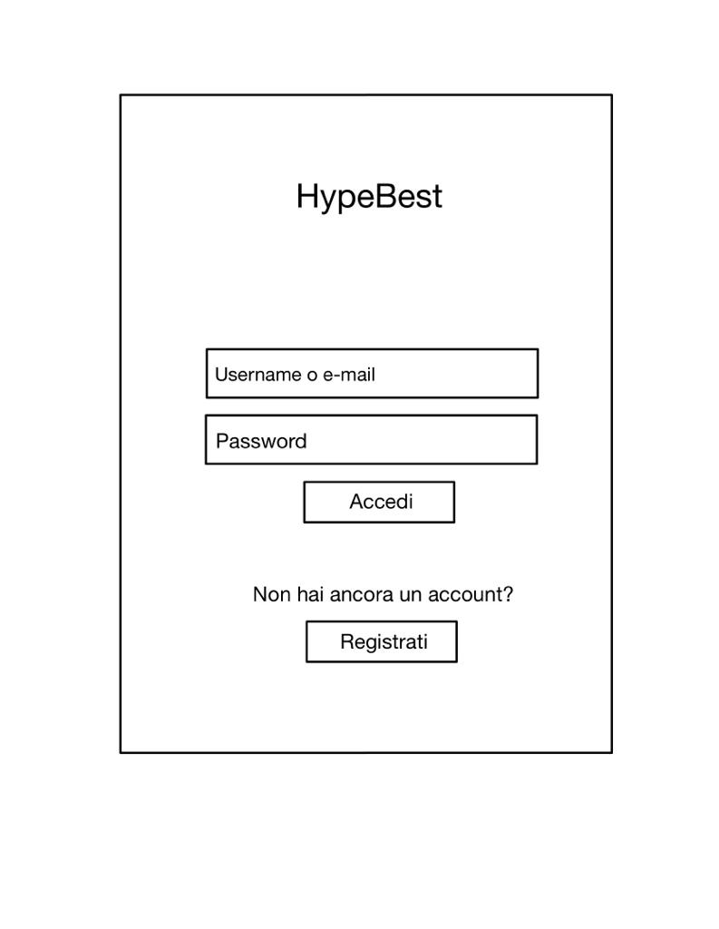

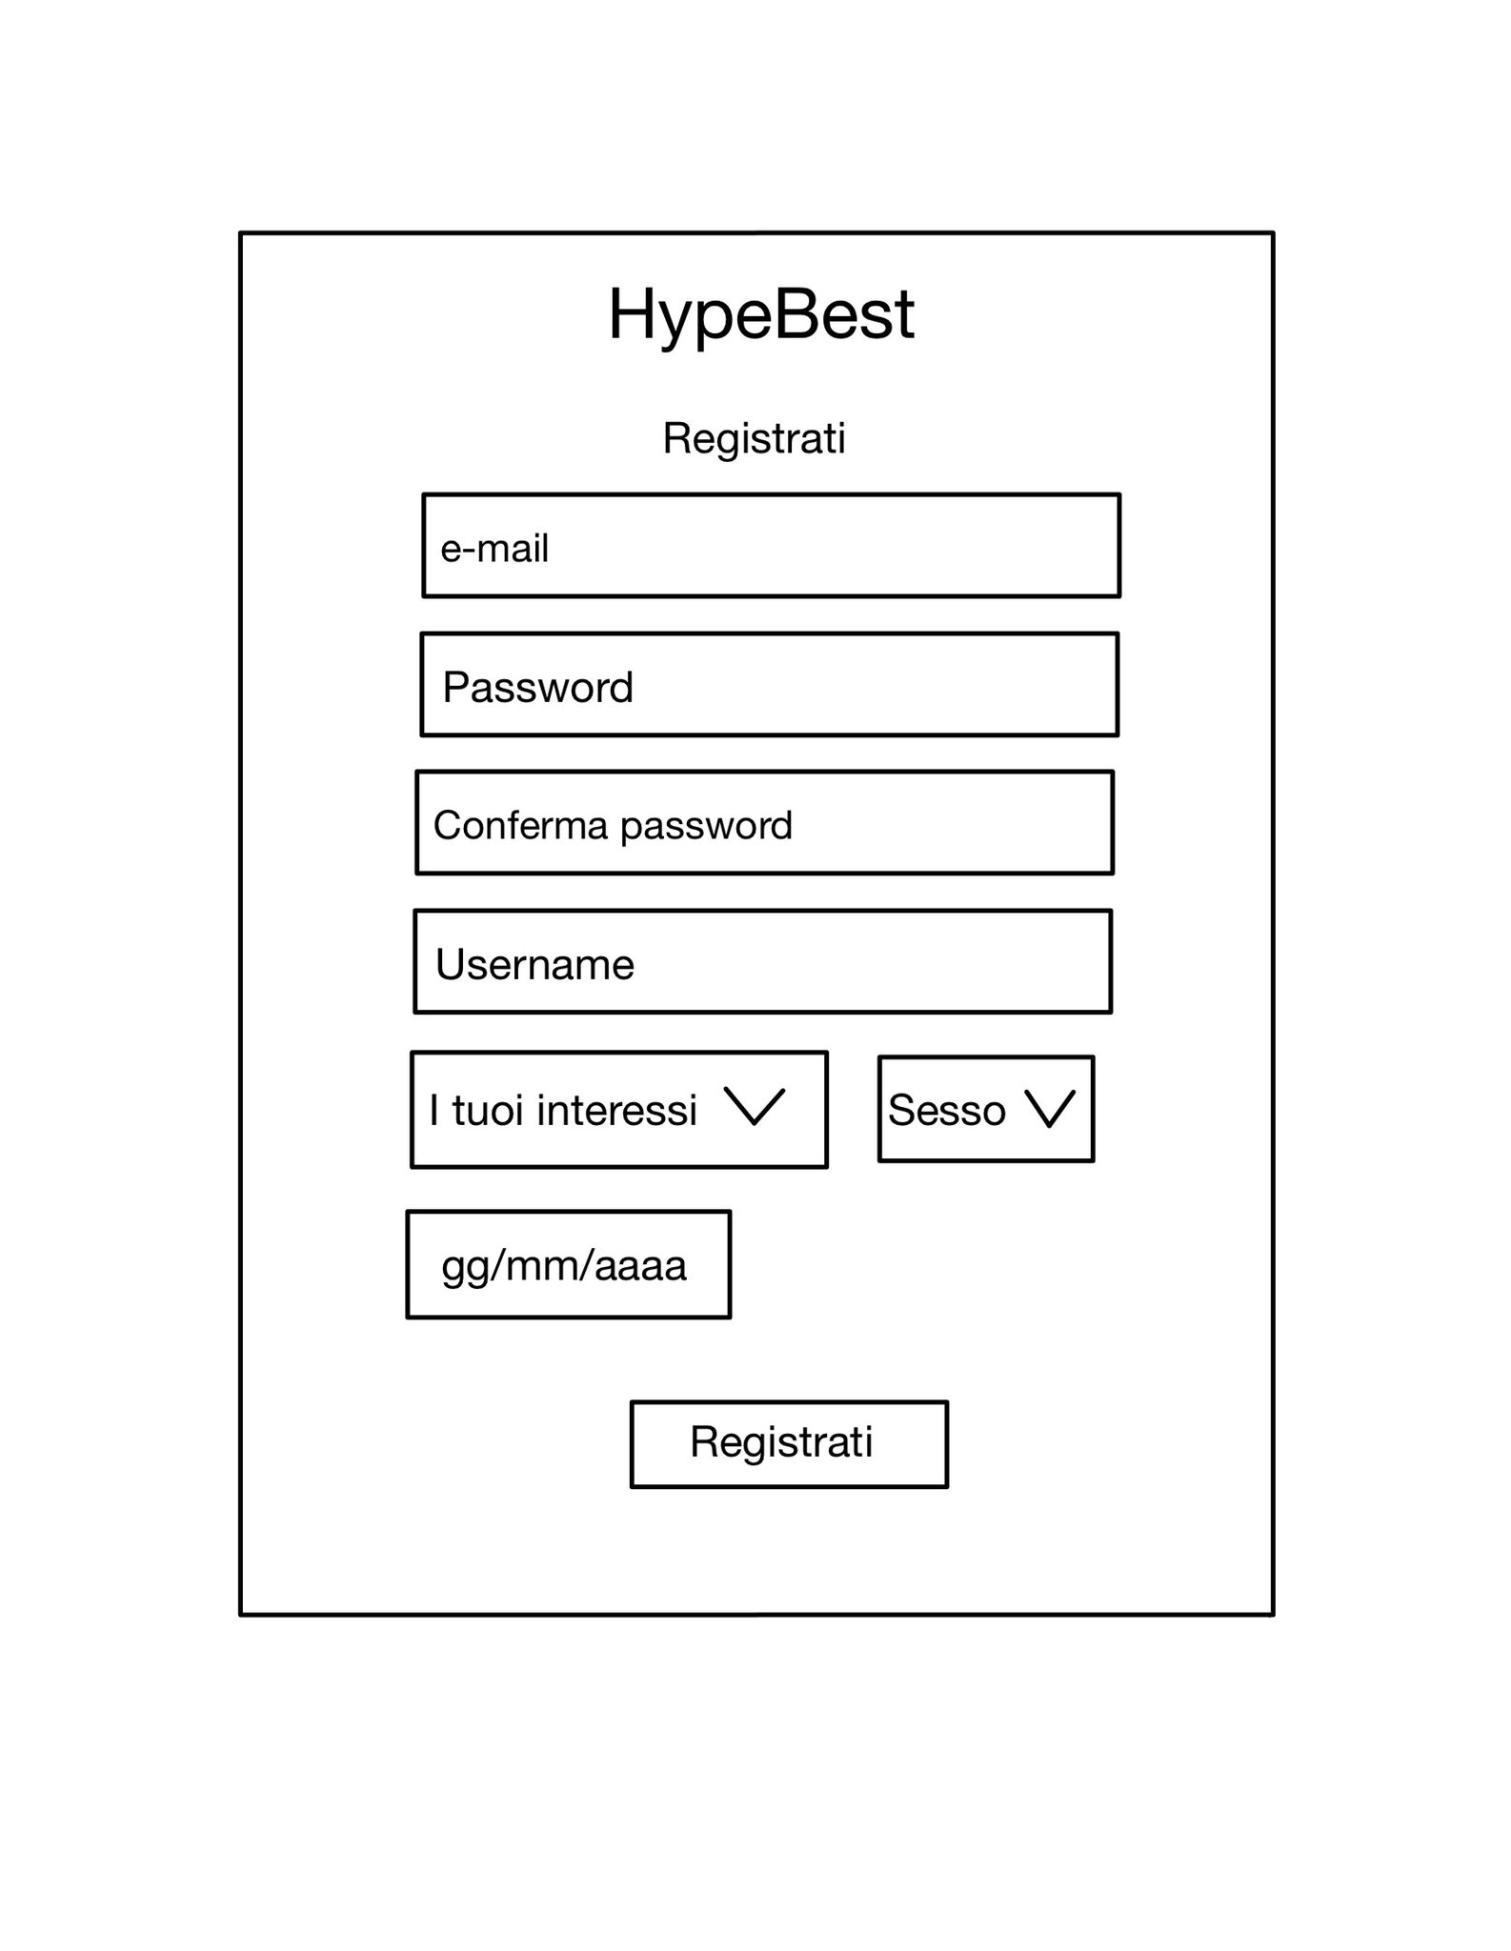

General description of the system

Descrizione del punto 3

Context and interfaces

Include a Context Diagram (DFD 0) in which the external organizations and the information that the system must share with these are identified. The limits of the system defined in the diagram has to be in line with the described scope in the previous chapters.

Example of a DFD …

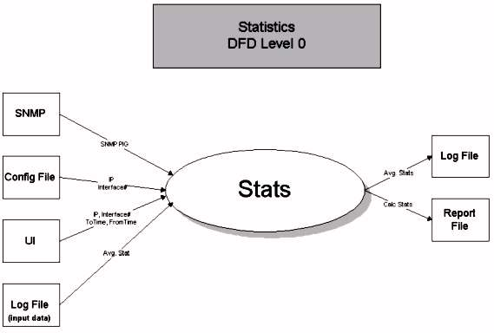

Design of the architecture

The Architecture constitutes the set of technical elements necessary for the operation of the system to be constructed. It can be provided and/or be designed by the client, or must be analyzed and be built by JM team (in the case of systems with a greater technological complexity or of systems integration).

In most of projects the Architecture is not design object, but a set of technical requirements practically fix throughout the system life cycle that form the stable environment of the client. In these cases this section is complimented indicating “Not applicable” or “N/A”. This is only possible if the client provides the specification of the architecture.

On the other hand, the architecture is a main part of the system design in a way that the fulfillment of functional or technical requirements depends on the elaboration of a design adapted to the architecture.

Faremo uso di un sito web e app mobile con un database e server…..

Requirements related to the architecture

Specify these requirements that have an impact on the architecture.

REQUIREMENT | CONSEQUENCES FOR ARCHITECTURE
RQF00001 | Functional req.00001  Xxxxxxxxxxxxxxxxxxxxxxxxxxxxxxx  Xxxxxxxxxxxxxxxxxxx xxxxxxxxxxxxxxxxxxx
RQT00003
RQO00006

Scenario and elements of the architecture

The design of the scenario should not detail the versions or specific configuration themes that may change between the different environments.

Components of the architecture

Put into relation the elements of the architecture dividing them by the different element types and the functions that they are carrying out.

COMPONENT | FUNCTION TO CARRY OUT
BEA App. server. | App. Server

- Function to be carried out: what is it thought for within the project.

Operating systems and hardware architecture

List the hardware and basic software elements of the system.

MANUFACTURER - MODEL | CARACTERISTICS | CONFIGURATION | OPER. SYSTEM
Server
DataBase

Scenario Diagrams

Useremo Visual Studio Code sfruttando il linguaggio React con le varie librerie aggiuntive
Utilizzeremo il linguaggio SQL per la gestione del database
Avremo un server….

Software architecture

Include a text as introduction. Example:
“The architecture of the software is based on component types that are specified on the following pages. The specifications about the component types and the form of their integration with the other components in order to build the system functions are described.”

Software components and integration model

Specify for every used component the following:
- Description (Component type)
- Component type that it uses/invokes and the methods
- Component types from which it is invoked and the used methods

See example:

TYPE OF COMPONENT | INVOKES A (TYPES) | IS INVOKED BY (TYPES)

Add further information about the used component types if necessary.

Correspondence software components / system functions

Describe in a structured form the components that are needed to create a function of the system. Normally in a system there is more than one way to build functions (transaction, to trigger, etc.) from components.

Example:
- “The presentation/ batch functions … are composed by the component CCCCCCCC and the following components of type TTTTTTTT organised in the following form:”
- “The functions of …”

It may be described also with a scheme, e.g.:

Screen
TRANSACTION
COBOL Program
Presentation
modules
Logical business
modules
Data access
modules

External Design

Describe the interfaces with the system. This includes those of human interaction (screens, navigator, etc.) as well as the interfaces with external systems.

The description of these interfaces should be maintained abstract and as independent as possible from the used technology. In the case of interfaces with other systems, the specification is centred in the aspects of the intercommunication and their details, including the technologies used for the interface. On the other hand, in the case of a user interface a more detailed description of each interface must be done including the image or graphical design, like the detailed relation of the actions and events of each one.

As an example the following text may be included:
“The external design describes the level of presentation and application layer (model OSI) of each of the interfaces with users and with other systems detailed in the context diagram (to see chapter 2.2).”

User interfaces are documents, reports and screens, understanding as screen in a wide definition any display device using text and/or graphical elements that allow to communicate with the system.

In case of using a tool for the design and/or construction of user Interfaces the part of External Design should be substituted by the information generated by the tool. The documents or objects where the designs are stored must be treated like components of the system with the object stored in repositories and of version control.

Layout standards and style guides

Include an introduction text if necessary. Example:
“In order to assure that the user interfaces fulfil the quality requirements, corporate image, uniformity, intelligibility, attractivity and related legal norms, the user interfaces have been developed in agreement with the following standards of layout and style guides. These include general specifications and particular specifications of the project”.

Screen standards

Define standards for screen styles. It may be included for example:
- Headers.
- Logos.
- Typography and colours (fonts and pantones).
- Visual structure and positioning of the presentation elements.
- Main menu bar.
- Positions of the buttons.
- Banners and advertisements.
- Function keys.
- Portlets.
- Languages (multi-language).
- Personalisation.
- Message areas for responses and errors.
- Any other resource or common structure.
- Sizes (in pixels or characters).
- Supported navigators.
- Common elements in all screens.
- Location of the elements.

Report and document standards

For reports and documents standards should be established for the following aspects:
- Headers.
- Logos.
- Legal elements in commercial documents (commercial register, etc.).
- Typography and colours (fonts and pantones).
- Languages (multi-language).
- Inserted advertisement.
- Sizes (DIN A4, 8,5x11”, etc.)
- Common elements for all documents and/or reports.

Details of user screen interface

Flow chart for navigation of the interface

Include a flow chart for the navigation between the system screens. All screens must be represented in the diagram together with their relation between them.

If the system navigation differs depending on profiles, groups, roles or on personal level, the diagram must be designed completely.

As an example …

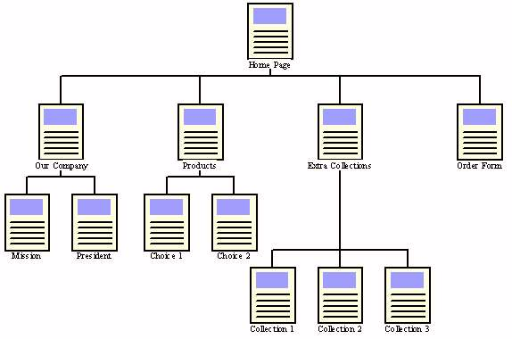

Summary of user interfaces – Screens and windows

Describe all the screens and windows of the system.

ID. SCREEN OR WINDOW | DESCRIPTION | SUPPORTED FUNCTION
Home | Una home contenente alcuni post degli utenti che si seguono
Cerca | Una pagina che permette di ricercare post in base a dei filtri applicati
Aggiungere | Una pagina che permette di pubblicare post che rispettino i requisiti di post specificati
Profilo | Una pagina che visualizzerà tutti i post dell’utente e le sue informazioni
Login/registrazione | Una pagina che permetterà all’utente di accedere al profilo o eventualmente crearne uno nuovo

Details of the user interfaces – Screens and windows

U. I. screen (1...n)

Specify the aspect and characteristics of each screen. Include so many sections as screens exist. It will not be necessary to include this section supposing that a tool is used. Include aspects such as:
- Identification of the screen or window.
- Description of them.
- Which components interact between the system and the user in this interface.
- Existing restrictions due to requirements of the user interface.
- Graphic layout of the user interface. Include a design sample or a graphic draft.
- Data fields. Depending on the technology and the special case should be defined for every screen:
  - Position.
  - Data source.
  - Input / Output.
  - Data type from the data dictionary.
  - Special Attributes: ¿Is translatable? (text multi-language), ¿Is convertible? (Numeric data in different types of units or currencies), etc.
  - Validation rules of the screen or coming from the data dictionary.
  - Previewed error cases, messages, actions (applied to input fields).
  - Default values (applied only to input fields).
  - Actions depending on field events: get-focus/lost focus, function keys, etc.
  - Pull down for context help (input fields).
- Other input/output elements. Depending on the technology and the special case should be defined for every element:
  - Position.
  - Validation rules of the screen or coming from the data dictionary.
  - Previewed errors, messages, actions.
  - Default values (input fields).
  - Actions depending on event cases of the element.
- Input/ output with peripheral equipment:
  - Bar code reader.
  - Scanner.
  - Cash Dispenser.
- Actions and transitions (function keys, buttons, menu options, links, etc). Describe each action that can take place from the screen. The description of each transition must include the action of user who qualifies it (PFs, button, Link) and the navigation destination or process that it initiates. The common transitions to all the interfaces of the system should not be described in a detailed form. This will be done in the section of Screen Standards.
- Local Personalización. The capacity of the interface to act in a different form according to profiles, groups, rolls, or even at individual level must be explained.

Details of the user interface for reports

Report (1 ... n)

Specify the aspect and characteristics of each report. Include so many sections as reports exist. It will not be necessary to include this section supposing that a tool is used. In opposite case include aspects such as:
- Report description.
- Model format (template/layout).
- Header data and structure.
- Data of every column of the report.
- Report structure.
- Groups: How to group and sort the report.
- Totals: sub-totals and totals
- Print-formats: print preview, AFP, HP, POSTCRIPT, PDF, etc.
- Export formats: MS Word, MS Excel, HTML, XML, etc.

Details of the user interface for documents

Document (1 ... n)

Specify the aspect and characteristics of each document. Include so many sections as documents exist. It will not be necessary to include this section supposing that a tool is used. In opposite case include aspects such as:
- Description.
- Model format (template/layout).
- Document data.
- Print formats: print preview, AFP, HP, POSTCRIPT, PDF, etc.
- Export formats: MS Word, MS Excel, HTML, XML, etc.
- Supported peripheral units (hardware).

Interfaces with other systems / applications

System Interface – (1...n)

The description of the interfaces with other systems is centred in the details of logical content, not in the solution of technological connectivity that is object of the architecture.

Description of the interface concept

Include for every interface a simple description or a general overview. This should be according to the context diagram from the Concept design. As an example:
“The interface of …. Allows to send/receive/use/… the services of …”

External system

Identify the related external system. Example:
“The interface interacts with the system …”

Content

Explain the elements of the interface. Detail more or less the object methods, API parameters, protocols, etc. depending on the technology If these elements are detailed sufficiently, they should be presented within a table.

Include aspects like:

- General parameters: data length, character set (may be important in some cases), etc.
- Detail parameters:
  - (data-1) – data type xxx
  - (data-2) – data type yyy
- Methods to invoke.
- ….

Logical Data Model

Analyze in detail the system data, generating a Entity/Relationship diagram, and the description of each one of the entities with its main attributes, the relations between organizations and the data dictionary. It should be done following the normal forms, recommending to reach third normal form.

In case of using a data design tool, replace the following sections by the information generated from the tool. The documents or objects where the designs are stored must be treated like system components. They are object of storage in repositorios and of version control.

Entity-Relation Diagram

Include a graphic presentation of the Data Model observing:

- Data entities.
- Relations between the entities.
- Numbering.

This diagram may be done with the help of a data modelling tool or a painting tool. Example:

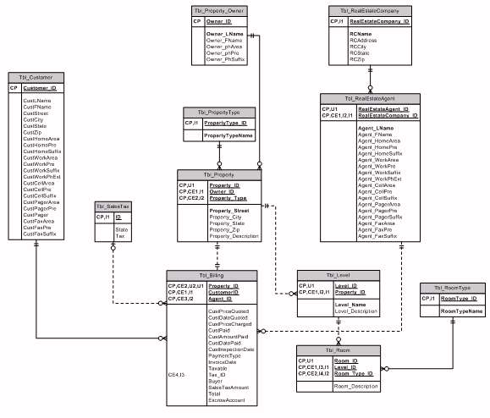

Entity details

Entity (E - 1..n)

Entity description

Describe the different entities of the system.

Column details

Description of the column | Class of data type from data dictionary | Keys and other attributes

- Column description: name of the column.
- Class of data type in the dictionary: data name in the data dictionary (name, site, DNI, etc.) Do not indicate information type N8, Char (14), etc. because this type of information is included in the Data dictionary from the Technical Design.
- Keys and other attributes: indicate if the column is part of any primary, secondary or external key.

Actions by entity events

Describe the defined actions as processes of the technical design that are released by events of an entity.

EVENT AND MOMENT OF THE ACTION | DESCRIPTION OF THE ACTION TO DO
(Event: new, delete, modification, …)
(moment: pre or post)

Relations between entities

Describe the necessary information for every relation.

RELATION NMAE | PRIMARY ENTITY | DIRECT ACTION | SECONDARY ENTITY | INVERSE ACTION | CARDINALITY

- Relation name: Id. of the relation.
- Primary entity: name of entity 1.
- Secondary entity: name of entity 2.

Data Dictionary

This is the catalogue of the logical data types for the system. Every column of an entity of the data model must be assigned to one data type from the dictionary. The physical data type configuration (N10, char(14), etc.) is explained in the Technical Design.

DATA TYPE | ALIAS OF THE DATA TYPE | DESCRIPTION | VALUES AND RANGES | RULES | ORIGINAL TYPE
Date | Date | General dates | 01.01.1900 a 31.12.2100
Expiry date | Expiry |  |  |  | Date
CCC |  | Account code cl. |  | CCC

- Data type: data name in the dictionary. Must be unique. E.g. a data type “DNI” may exist that may be included as column in different entities.
- Alias of the data type: other names indicated as alias.
- Description: description of the data types.
- Values and ranges: notation, cases, value ranges, default values, etc.
- Rules: validation and integrity rules.
- Original type: If necessary, name of other “data type” (column 1 of the table) from the dictionary from which type gets its basic properties.

Logical Process Model

Beginning with the system defined in Conceptual Design and the Requirements of the Client, the Logical Process Model descends to a greater detail level, until a very exact descriptionof the basic system functions, their relations with the data, and the exchanges with the external system interfaces.

Details of the subsystems

Layers or system partitions

Depending on the technology, the project type and the clients preferences this Logical Process Model (process of decomposition in elementary functions) may be done with an object oriented design. In this case it is normal to use UML (use case diagrams, collaboration diagrams, etc.), Flow charts (DFDs) or other technologies.

So many sections of subsystems will be created as it is necessary.

Details of the subsystem 1...n

Include the necessary diagrams with a higher detail level to understand the system or its description.

Detailed design of basic functions (structured design)

Function AAAAAAA (1...n)

Describe:
- Storage of data related to the function
- Related business requirements
- Related external interfaces (users/external systems)
- Event or starting method
- …

